**LAPORAN PRAKTIKUM DESAIN WEB 10**

“Merubah Template”



Nama :

Diva Cahya Hakim - 4523210037

**Dosen : Adi Wahyudi Pribadi**

**S1 Teknik Informatika**

**Fakultas Teknik**

**Universitas Pancasila**

**2024/2025**

Tampilan sebelum diubah

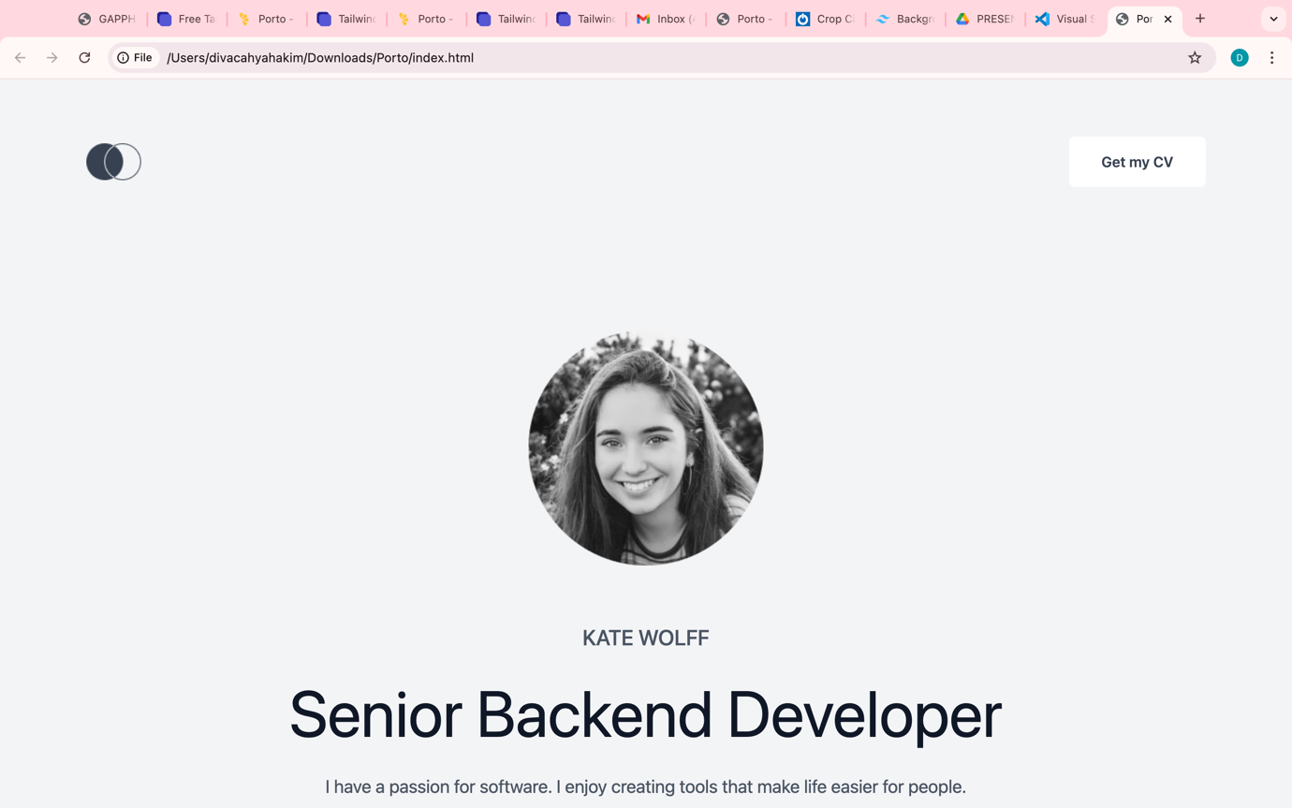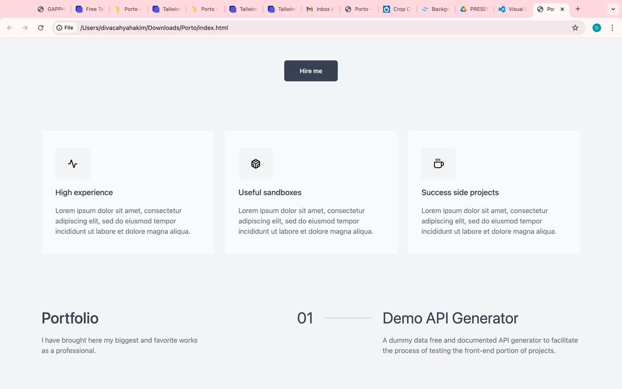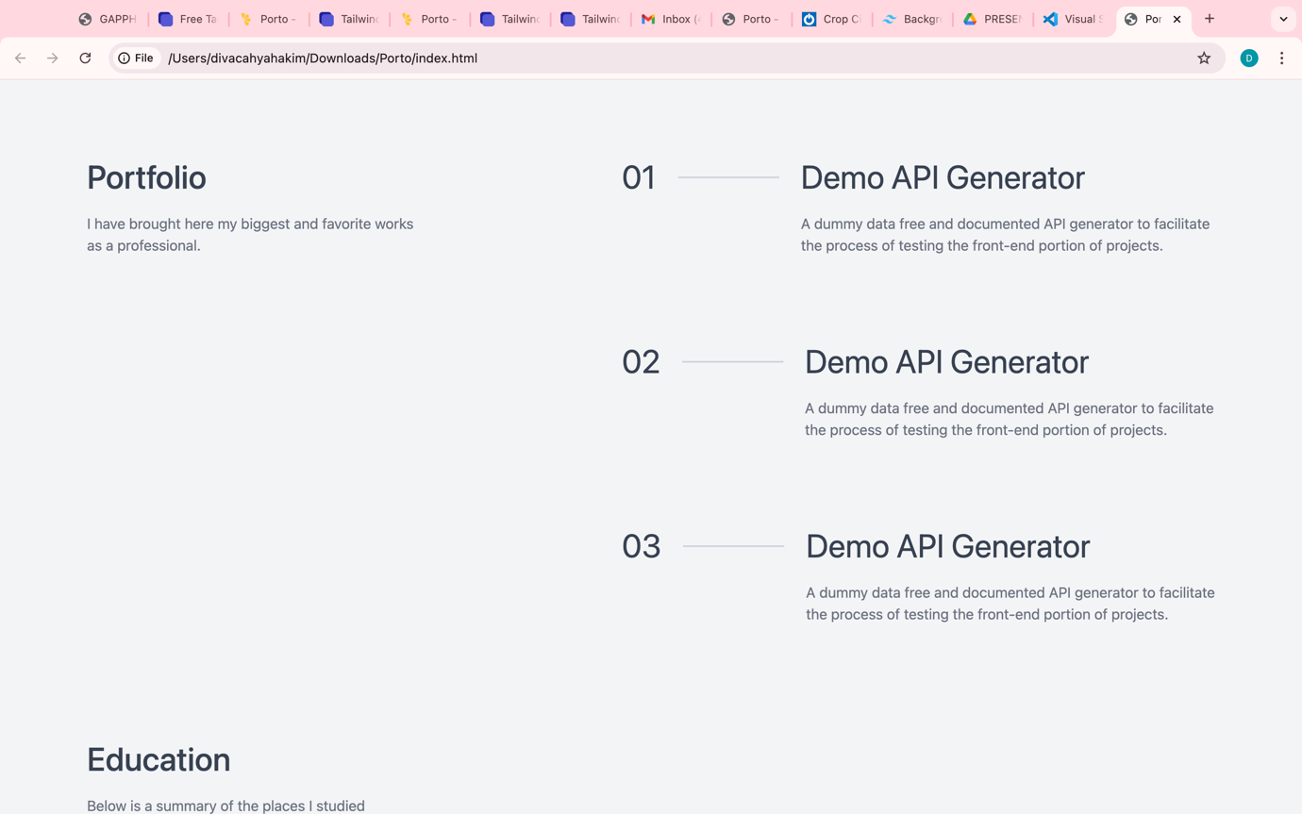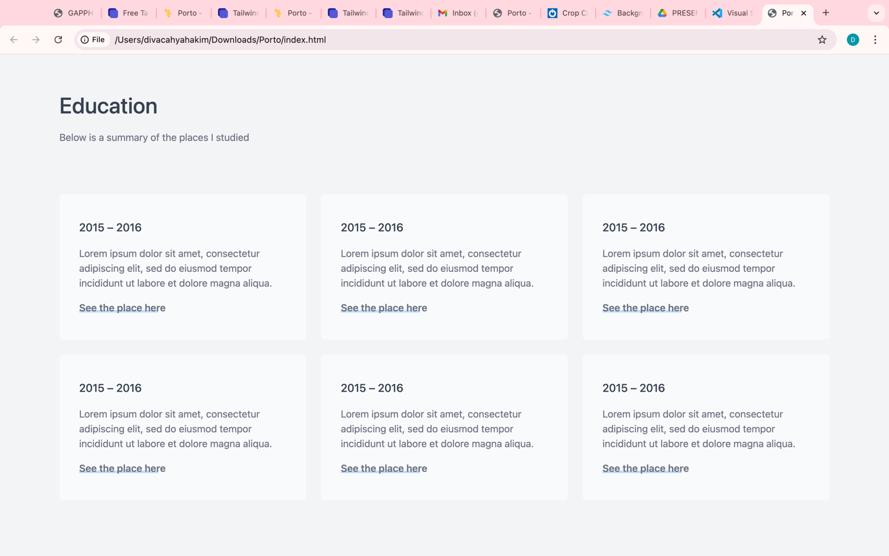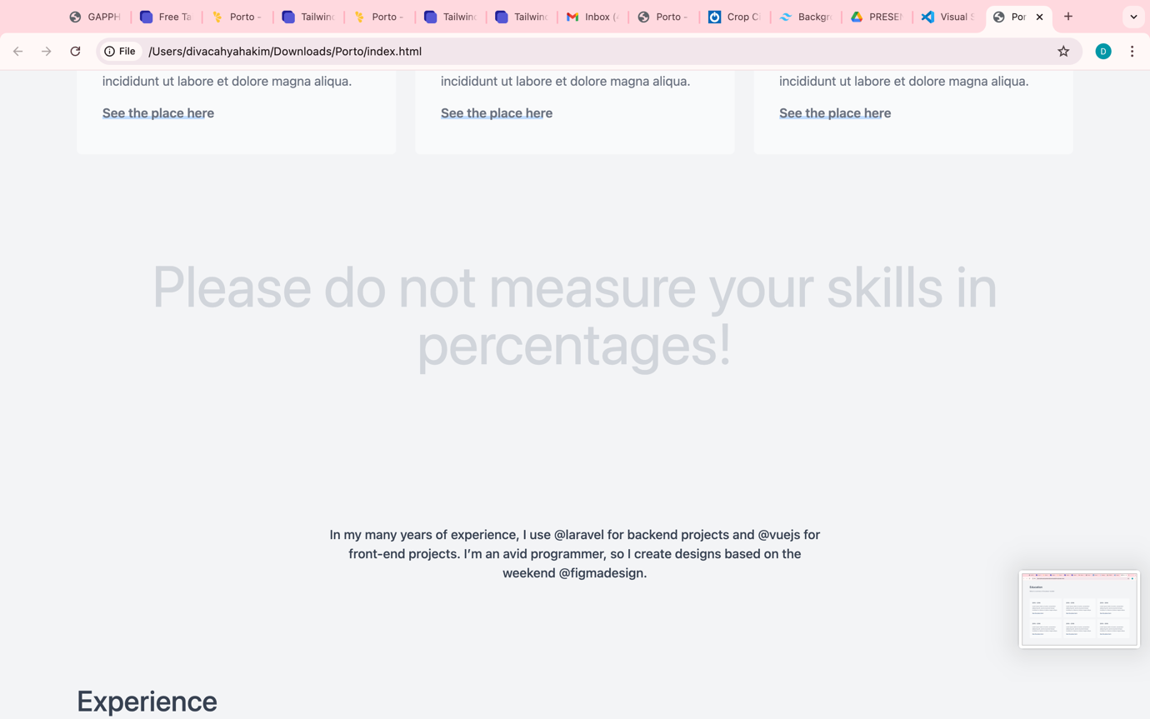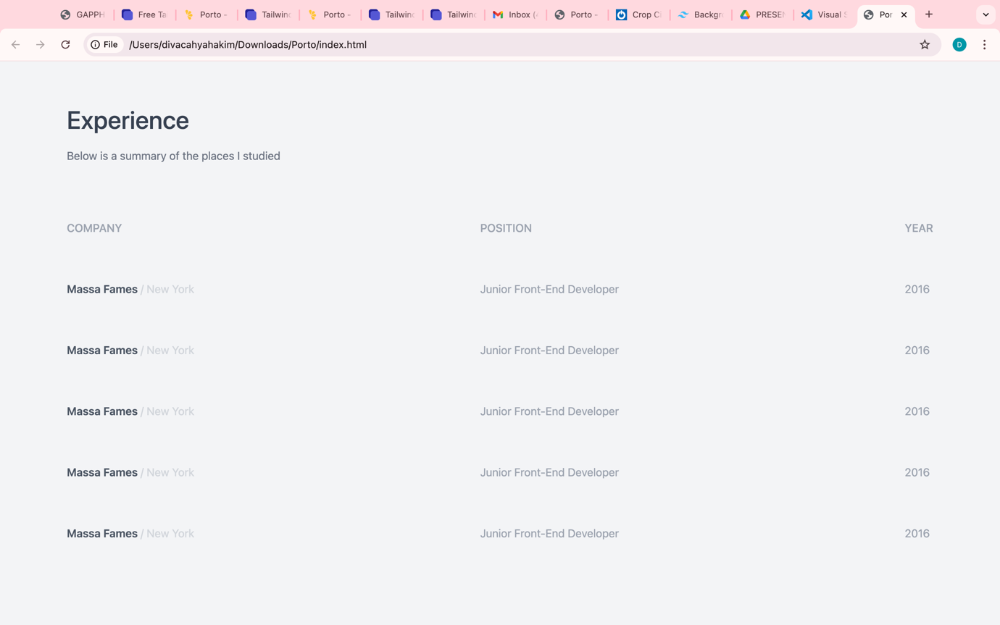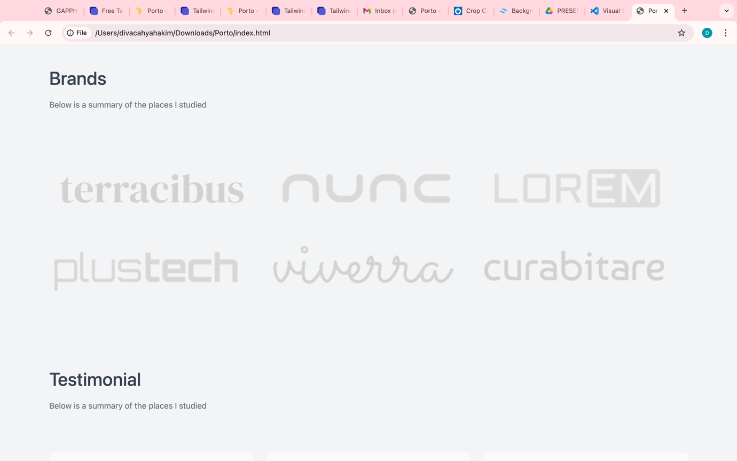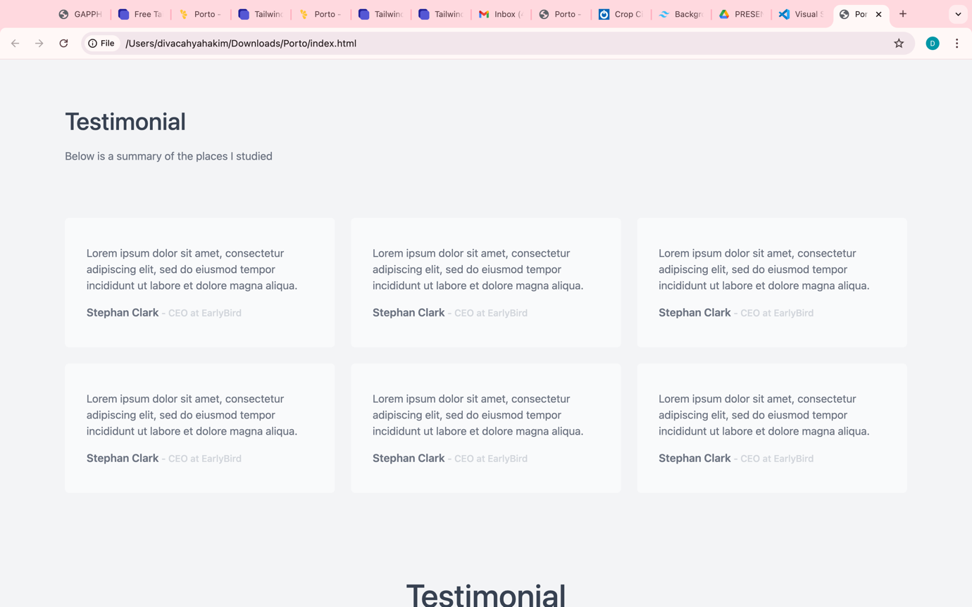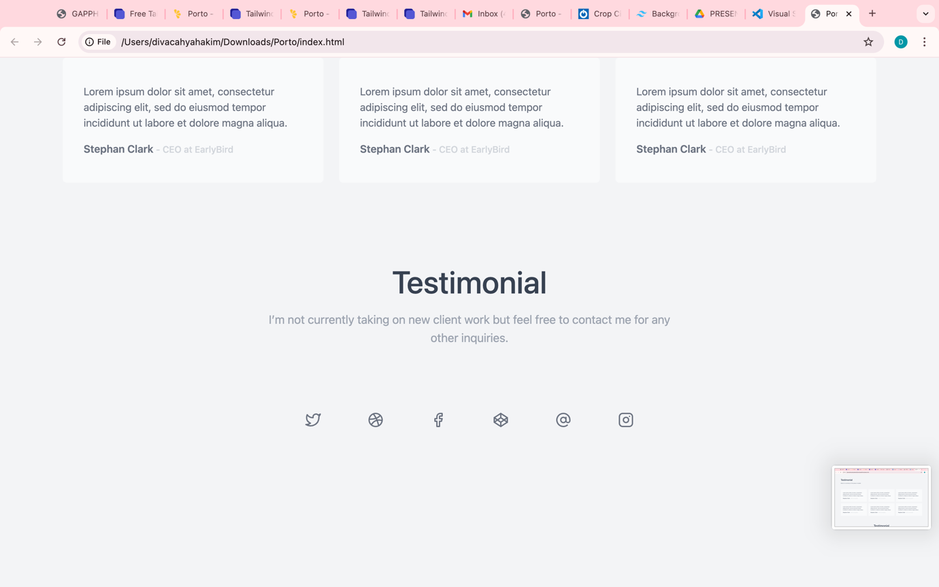

Tampilan sesudah di ubah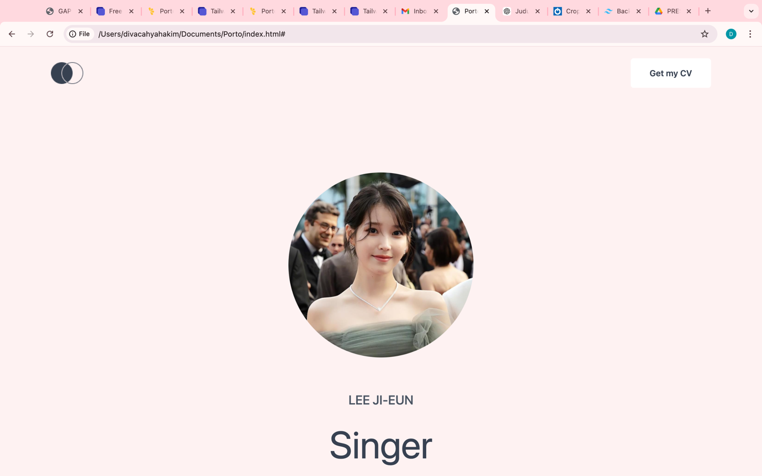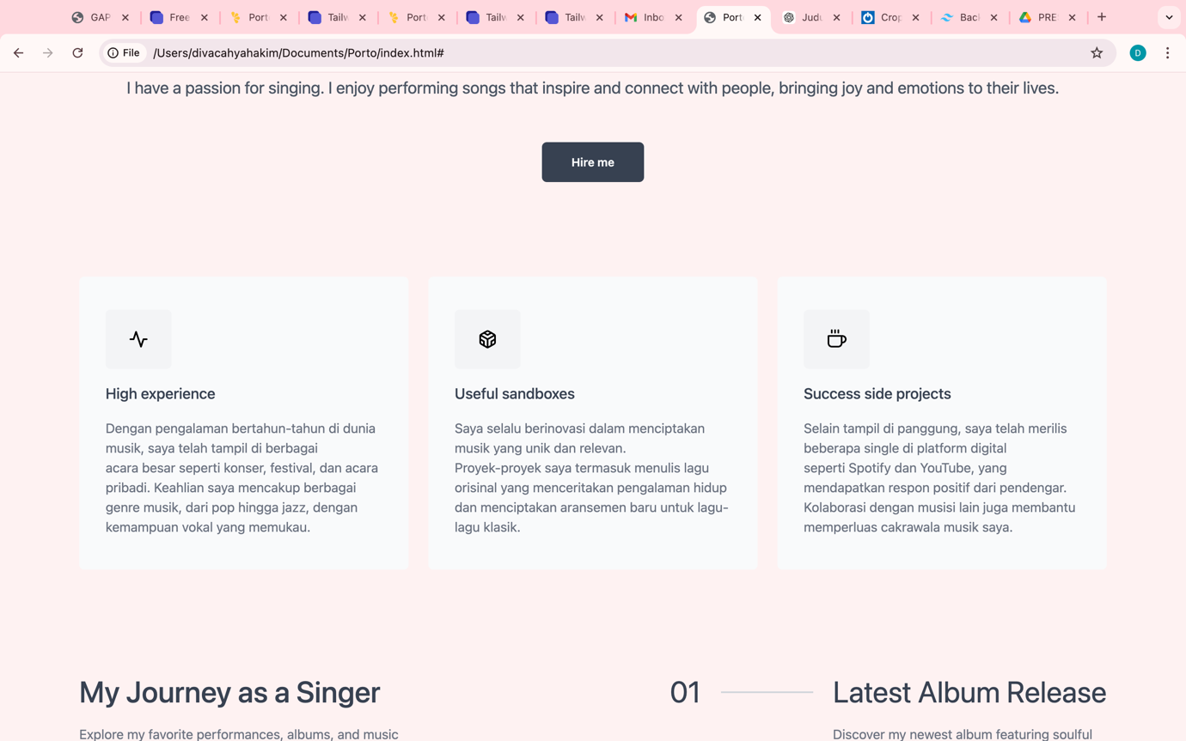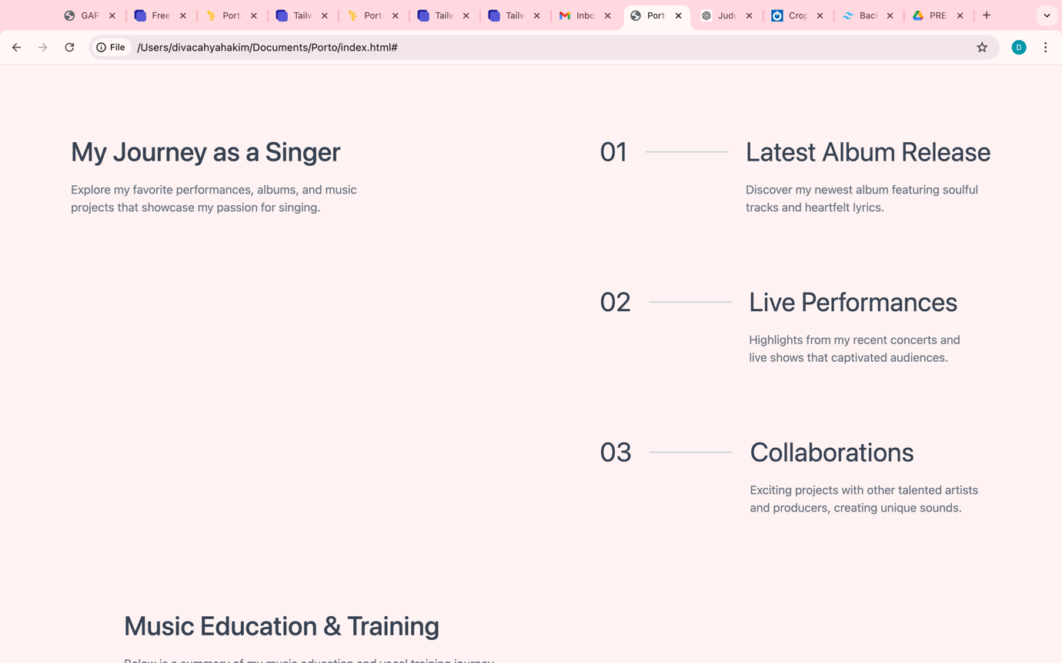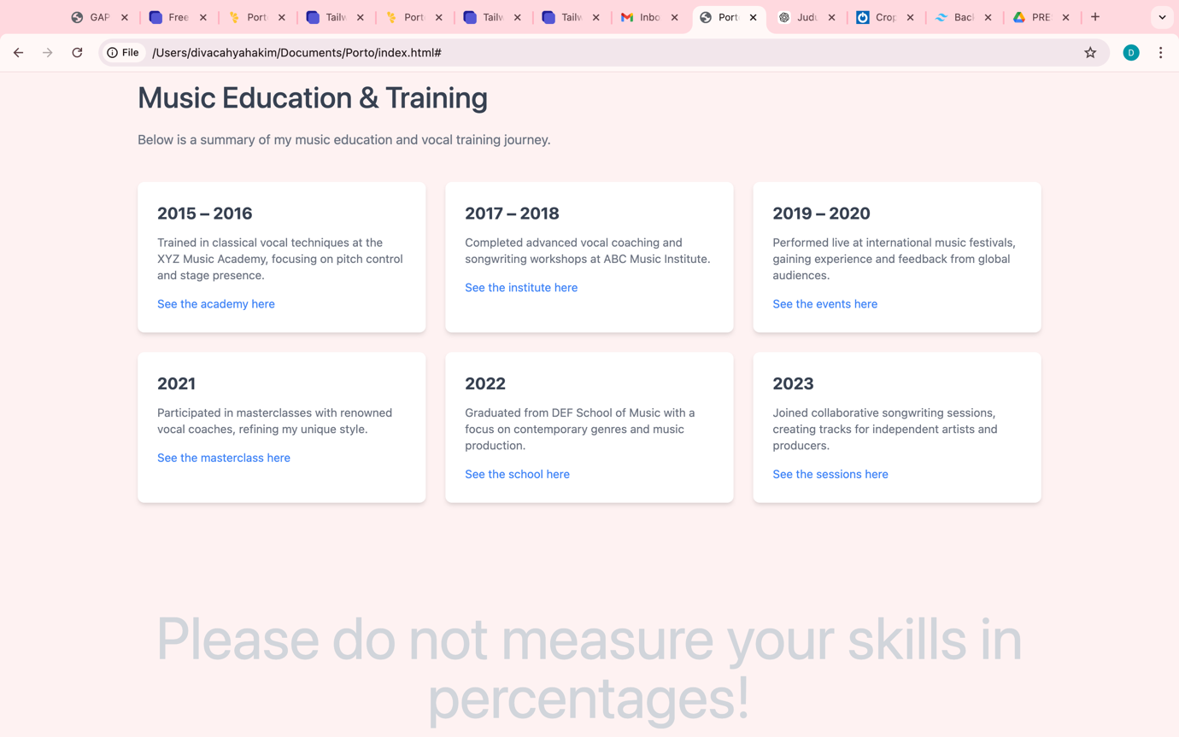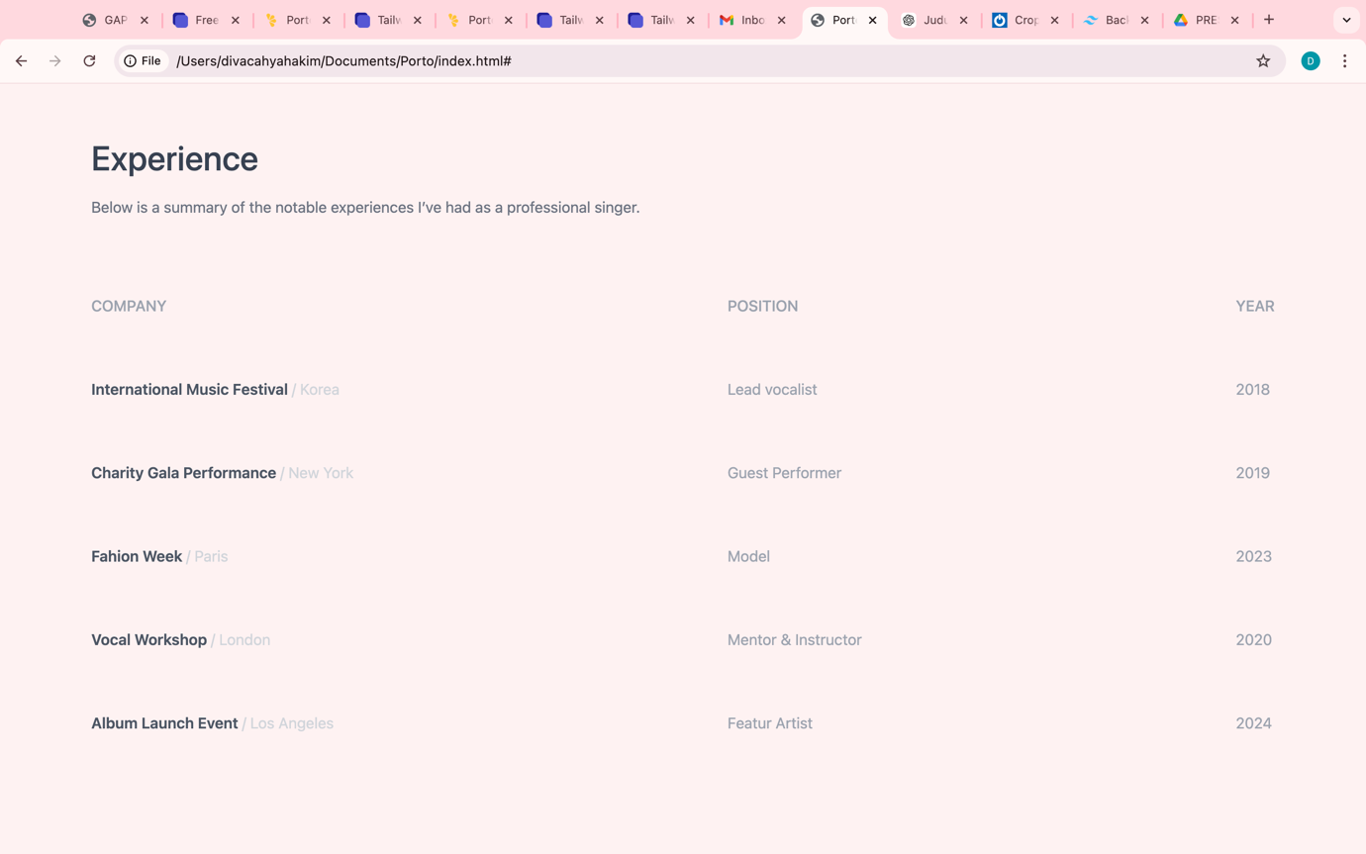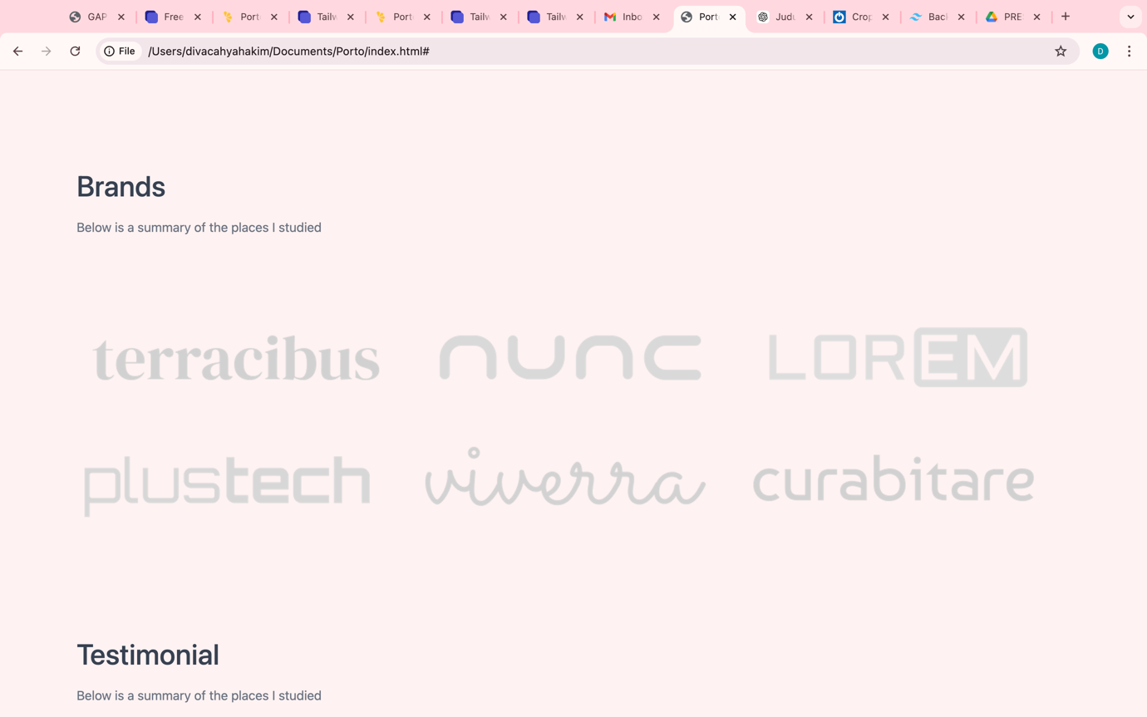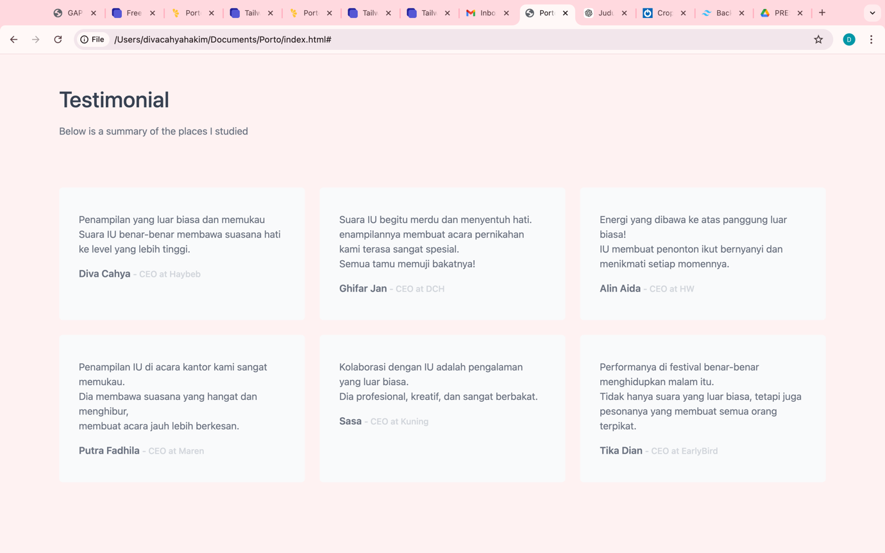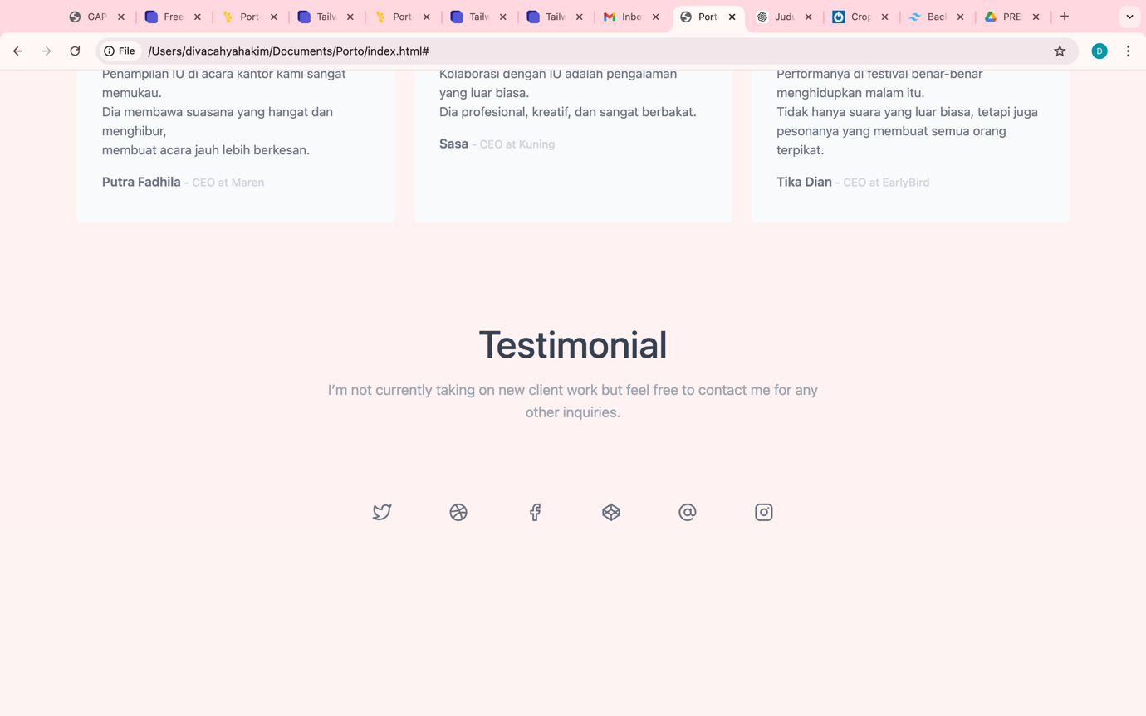

Codingan yang suda di ubah

<!DOCTYPE html>

<html lang="en">

<head>

<meta charset="UTF-8">

<meta http-equiv="X-UA-Compatible" content="IE=edge">

<meta name="viewport" content="width=device-width, initial-scale=1.0">

<title>Porto - Tailwind Template</title>

<link rel="stylesheet" href="assets/css/tailwind.css">

<link rel="preconnect" href="https://fonts.googleapis.com">

<link rel="preconnect" href="https://fonts.gstatic.com" crossorigin>

<link href="https://fonts.googleapis.com/css2?family=Poppins:wght@400;500;600;700;800&display=swap" rel="stylesheet">

<script src="https://cdnjs.cloudflare.com/ajax/libs/feather-icons/4.28.0/feather.min.js" integrity="sha512-7x3zila4t2qNycrtZ31HO0NnJr8kg2VI67YLoRSyi9hGhRN66FHYWr7Axa9Y1J9tGYHVBPqIjSE1ogHrJTz51g==" crossorigin="anonymous" referrerpolicy="no-referrer"></script>

</head>

<body class="bg-red-50">

<section class="py-10 md:py-16">

<div class="container max-w-screen-xl mx-auto px-4">

<nav class="flex items-center justify-between mb-40">

<img src="assets/image/navbar-logo.png" alt="Logo">

<button class="px-7 py-3 md:px-9 md:py-4 bg-white font-medium md:font-semibold text-gray-700 text-md rounded-md hover:bg-gray-700 hover:text-white transition ease-linear duration-500">Get my CV</button>

</nav>

<div class="text-center">

<div class="flex justify-center mb-16">

<img src="assets/image/iu.png" alt="Image" width="350px">

</div>

<h6 class="font-medium text-gray-600 text-lg md:text-2xl uppercase mb-8">Lee Ji-eun</h6>

<h1 class="font-normal text-gray-700 text-4xl md:text-7xl leading-none mb-8">Singer</h1>

<p class="font-normal text-gray-600 text-md md:text-xl mb-16">I have a passion for singing. I enjoy performing songs that inspire and connect with people, bringing joy and emotions to their lives.</p>

<a href="#" class="px-7 py-3 md:px-9 md:py-4 font-medium md:font-semibold bg-gray-700 text-gray-50 text-sm rounded-md hover:bg-gray-50 hover:text-gray-700 transition ease-linear duration-500">Hire me</a>

</div>

</div>

</section>

<section class="py-10 md:py-16">

<div class="container max-w-screen-xl mx-auto px-4">

<div class="grid grid-cols-1 md:grid-cols-2 lg:grid-cols-3 gap-6">

<div class="bg-gray-50 px-8 py-10 rounded-md">

<div class="w-20 py-6 flex justify-center bg-gray-100 rounded-md mb-4">

<i data-feather="activity"></i>

</div>

<h4 class="font-medium text-gray-700 text-lg mb-4">High experience</h4>

<p class="font-normal text-gray-500 text-md">Dengan pengalaman bertahun-tahun di dunia musik, saya telah tampil di berbagai <br>

acara besar seperti konser, festival, dan acara pribadi. Keahlian saya mencakup berbagai <br>

genre musik, dari pop hingga jazz, dengan kemampuan vokal yang memukau.</p>

</div>

<div class="bg-gray-50 px-8 py-10 rounded-md">

<div class="w-20 py-6 flex justify-center bg-gray-100 rounded-md mb-4">

<i data-feather="codesandbox"></i>

</div>

<h4 class="font-medium text-gray-700 text-lg mb-4">Useful sandboxes</h4>

<p class="font-normal text-gray-500 text-md">Saya selalu berinovasi dalam menciptakan musik yang unik dan relevan.<br>

Proyek-proyek saya termasuk menulis lagu orisinal yang menceritakan pengalaman hidup <br>

dan menciptakan aransemen baru untuk lagu-lagu klasik.</p>

</div>

<div class="bg-gray-50 px-8 py-10 rounded-md">

<div class="w-20 py-6 flex justify-center bg-gray-100 rounded-md mb-4">

<i data-feather="coffee"></i>

</div>

<h4 class="font-medium text-gray-700 text-lg mb-4">Success side projects</h4>

<p class="font-normal text-gray-500 text-md">Selain tampil di panggung, saya telah merilis beberapa single di platform digital<br>

seperti Spotify dan YouTube, yang mendapatkan respon positif dari pendengar. <br>

Kolaborasi dengan musisi lain juga membantu memperluas cakrawala musik saya.</p>

</div>

</div>

</div>

</section>

<section class="py-10 md:py-16">

<div class="container max-w-screen-xl mx-auto px-4">

<div class="flex flex-col lg:flex-row justify-between">

<div class="mb-10 lg:mb-0">

<h1 class="font-medium text-gray-700 text-3xl md:text-4xl mb-5">My Journey as a Singer</h1>

<p class="font-normal text-gray-500 text-xs md:text-base">Explore my favorite performances, albums, and music <br>

projects that showcase my passion for singing.</p>

</div>

<div class="space-y-24">

<div class="flex space-x-6">

<h1 class="font-normal text-gray-700 text-3xl md:text-4xl">01</h1>

<span class="w-28 h-0.5 bg-gray-300 mt-5"></span>

<div>

<h1 class="font-normal text-gray-700 text-3xl md:text-4xl mb-5">Latest Album Release</h1>

<p class="font-normal text-gray-500 text-sm md:text-base">Discover my newest album featuring soulful <br> tracks and heartfelt lyrics.</p>

</div>

</div>

<div class="flex space-x-6">

<h1 class="font-normal text-gray-700 text-3xl md:text-4xl">02</h1>

<span class="w-28 h-0.5 bg-gray-300 mt-5"></span>

<div>

<h1 class="font-normal text-gray-700 text-3xl md:text-4xl mb-5">Live Performances</h1>

<p class="font-normal text-gray-500 text-sm md:text-base">Highlights from my recent concerts and <br> live shows that captivated audiences.</p>

</div>

</div>

<div class="flex space-x-6">

<h1 class="font-normal text-gray-700 text-3xl md:text-4xl">03</h1>

<span class="w-28 h-0.5 bg-gray-300 mt-5"></span>

<div>

<h1 class="font-normal text-gray-700 text-3xl md:text-4xl mb-5">Collaborations</h1>

<p class="font-normal text-gray-500 text-sm md:text-base"> Exciting projects with other talented artists <br>and producers, creating unique sounds.</p>

</div>

</div>

</div>

</div>

</div>

</section>

<section class="py-10 md:py-16">

<div class="max-w-6xl mx-auto px-6">

<div class=" mb-10">

<h1 class="font-medium text-gray-700 text-3xl md:text-4xl mb-5">Music Education & Training</h1>

<p class="font-normal text-gray-500 text-base">

Below is a summary of my music education and vocal training journey.

</p>

</div>

<div class="grid grid-cols-1 md:grid-cols-2 lg:grid-cols-3 gap-6">

<div class="bg-white shadow-md rounded-lg p-6">

<h2 class="font-bold text-gray-700 text-xl mb-3">2015 – 2016</h2>

<p class="text-gray-500 text-sm mb-3">

Trained in classical vocal techniques at the XYZ Music Academy, focusing on pitch control and stage presence.

</p>

<a href="#" class="text-blue-500 hover:underline text-sm">See the academy here</a>

</div>

<div class="bg-white shadow-md rounded-lg p-6">

<h2 class="font-bold text-gray-700 text-xl mb-3">2017 – 2018</h2>

<p class="text-gray-500 text-sm mb-3">

Completed advanced vocal coaching and songwriting workshops at ABC Music Institute.

</p>

<a href="#" class="text-blue-500 hover:underline text-sm">See the institute here</a>

</div>

<div class="bg-white shadow-md rounded-lg p-6">

<h2 class="font-bold text-gray-700 text-xl mb-3">2019 – 2020</h2>

<p class="text-gray-500 text-sm mb-3">

Performed live at international music festivals, gaining experience and feedback from global audiences.

</p>

<a href="#" class="text-blue-500 hover:underline text-sm">See the events here</a>

</div>

<div class="bg-white shadow-md rounded-lg p-6">

<h2 class="font-bold text-gray-700 text-xl mb-3">2021</h2>

<p class="text-gray-500 text-sm mb-3">

Participated in masterclasses with renowned vocal coaches, refining my unique style.

</p>

<a href="#" class="text-blue-500 hover:underline text-sm">See the masterclass here</a>

</div>

<div class="bg-white shadow-md rounded-lg p-6">

<h2 class="font-bold text-gray-700 text-xl mb-3">2022</h2>

<p class="text-gray-500 text-sm mb-3">

Graduated from DEF School of Music with a focus on contemporary genres and music production.

</p>

<a href="#" class="text-blue-500 hover:underline text-sm">See the school here</a>

</div>

<div class="bg-white shadow-md rounded-lg p-6">

<h2 class="font-bold text-gray-700 text-xl mb-3">2023</h2>

<p class="text-gray-500 text-sm mb-3">

Joined collaborative songwriting sessions, creating tracks for independent artists and producers.

</p>

<a href="#" class="text-blue-500 hover:underline text-sm">See the sessions here</a>

</div>

</div>

</div>

</section>

<section class="py-10 md:py-16">

<div class="container max-w-screen-xl mx-auto px-4">

<div class="text-center">

<h1 class="font-normal text-gray-300 text-3xl md:text-6xl lg:text-7xl mb-20 md:mb-32 lg:mb-48">Please do not measure your skills in <br> percentages!</h1>

<p class="font-medium text-gray-700 text-xs md:text-base">In my many years of experience, I use @laravel for backend projects and @vuejs for <br> front-end projects. I’m an avid programmer, so I create designs based on the <br> weekend @figmadesign.</p>

</div>

</div>

</section>

<section class="py-10 md:py-16">

<div class="container max-w-screen-xl mx-auto px-4">

<h1 class="font-medium text-gray-700 text-3xl md:text-4xl mb-5">Experience</h1>

<p class="font-normal text-gray-500 text-xs md:text-base mb-20"> Below is a summary of the notable experiences I’ve had as a professional singer.

</p>

<div class="flex flex-col lg:flex-row justify-between">

<div class="space-y-8 md:space-y-16 mb-16 md:mb-0">

<h6 class="font-medium text-gray-400 text-base uppercase">Company</h6>

<p class="font-semibold text-gray-600 text-base">International Music Festival <span class="font-normal text-gray-300">/ Korea</span></p>

<p class="font-semibold text-gray-600 text-base">Charity Gala Performance <span class="font-normal text-gray-300">/ New York</span></p>

<p class="font-semibold text-gray-600 text-base">Fahion Week <span class="font-normal text-gray-300">/ Paris</span></p>

<p class="font-semibold text-gray-600 text-base">Vocal Workshop <span class="font-normal text-gray-300">/ London</span></p>

<p class="font-semibold text-gray-600 text-base">Album Launch Event <span class="font-normal text-gray-300">/ Los Angeles</span></p>

</div>

<div class="space-y-8 md:space-y-16 mb-16 md:mb-0">

<h6 class="font-medium text-gray-400 text-base uppercase">Position</h6>

<p class="font-normal text-gray-400 text-base">Lead vocalist</p>

<p class="font-normal text-gray-400 text-base">Guest Performer</p>

<p class="font-normal text-gray-400 text-base">Model</p>

<p class="font-normal text-gray-400 text-base">Mentor & Instructor</p>

<p class="font-normal text-gray-400 text-base">Featur Artist</p>

</div>

<div class="space-y-8 md:space-y-16">

<h6 class="font-medium text-gray-400 text-base uppercase">Year</h6>

<p class="font-normal text-gray-400 text-base">2018</p>

<p class="font-normal text-gray-400 text-base">2019</p>

<p class="font-normal text-gray-400 text-base">2023</p>

<p class="font-normal text-gray-400 text-base">2020</p>

<p class="font-normal text-gray-400 text-base">2024</p>

</div>

</div>

</div>

</section>

<section class="py-10 md:py-16">

<div class="container max-w-screen-xl mx-auto px-4">

<h1 class="font-medium text-gray-700 text-3xl md:text-4xl mb-5">Brands</h1>

<p class="font-normal text-gray-500 text-xs md:text-base mb-10 md:mb-20">Below is a summary of the places I studied</p>

<div class="grid grid-cols-1 md:grid-cols-2 lg:grid-cols-3">

<img src="assets/image/brand-1.png" alt="Image">

<img src="assets/image/brand-2.png" alt="Image">

<img src="assets/image/brand-3.png" alt="Image">

<img src="assets/image/brand-4.png" alt="Image">

<img src="assets/image/brand-5.png" alt="Image">

<img src="assets/image/brand-6.png" alt="Image">

</div>

</div>

</section>

<section class="py-10 md:py-16">

<div class="container max-w-screen-xl mx-auto px-4">

<h1 class="font-medium text-gray-700 text-3xl md:text-4xl mb-5">Testimonial</h1>

<p class="font-normal text-gray-500 text-xs md:text-base mb-10 md:mb-20">Below is a summary of the places I studied</p>

<div class="grid grid-cols-1 md:grid-cols-2 lg:grid-cols-3 gap-6">

<div class="bg-gray-50 px-8 py-10 rounded-md">

<p class="font-normal text-gray-500 text-md mb-4">Penampilan yang luar biasa dan memukau <br> Suara IU benar-benar membawa suasana hati ke level yang lebih tinggi.</p>

<h6 class="font-semibold text-gray-500 text-md">Diva Cahya <span class="font-medium text-gray-300 text-sm">- CEO at Haybeb</span></h6>

</div>

<div class="bg-gray-50 px-8 py-10 rounded-md">

<p class="font-normal text-gray-500 text-md mb-4">Suara IU begitu merdu dan menyentuh hati. <br> enampilannya membuat acara pernikahan kami terasa sangat spesial. <br> Semua tamu memuji bakatnya!</p>

<h6 class="font-semibold text-gray-500 text-md">Ghifar Jan <span class="font-medium text-gray-300 text-sm">- CEO at DCH</span></h6>

</div>

<div class="bg-gray-50 px-8 py-10 rounded-md">

<p class="font-normal text-gray-500 text-md mb-4">Energi yang dibawa ke atas panggung luar biasa! <br> IU membuat penonton ikut bernyanyi dan menikmati setiap momennya.</p>

<h6 class="font-semibold text-gray-500 text-md">Alin Aida <span class="font-medium text-gray-300 text-sm">- CEO at HW</span></h6>

</div>

<div class="bg-gray-50 px-8 py-10 rounded-md">

<p class="font-normal text-gray-500 text-md mb-4">Penampilan IU di acara kantor kami sangat memukau. <br> Dia membawa suasana yang hangat dan menghibur, <br> membuat acara jauh lebih berkesan.</p>

<h6 class="font-semibold text-gray-500 text-md">Putra Fadhila <span class="font-medium text-gray-300 text-sm">- CEO at Maren</span></h6>

</div>

<div class="bg-gray-50 px-8 py-10 rounded-md">

<p class="font-normal text-gray-500 text-md mb-4">Kolaborasi dengan IU adalah pengalaman yang luar biasa. <br> Dia profesional, kreatif, dan sangat berbakat.</p>

<h6 class="font-semibold text-gray-500 text-md">Sasa <span class="font-medium text-gray-300 text-sm">- CEO at Kuning</span></h6>

</div>

<div class="bg-gray-50 px-8 py-10 rounded-md">

<p class="font-normal text-gray-500 text-md mb-4">Performanya di festival benar-benar menghidupkan malam itu. <br> Tidak hanya suara yang luar biasa, tetapi juga pesonanya yang membuat semua orang terpikat.</p>

<h6 class="font-semibold text-gray-500 text-md">Tika Dian <span class="font-medium text-gray-300 text-sm">- CEO at EarlyBird</span></h6>

</div>

</div>

</div>

</section>

<footer class="py-10 md:py-16 mb-20 md:mb-40 lg::mb-52">

<div class="container max-w-screen-xl mx-auto px-4">

<div class="text-center">

<h1 class="font-medium text-gray-700 text-4xl md:text-5xl mb-5">Testimonial</h1>

<p class="font-normal text-gray-400 text-md md:text-lg mb-20">I’m not currently taking on new client work but feel free to contact me for any <br> other inquiries.</p>

<div class="flex items-center justify-center space-x-8">

<a href="#" class="w-16 h-16 flex items-center justify-center rounded-full hover:bg-gray-200 transition ease-in-out duration-500">

<i data-feather="twitter" class="text-gray-500 hover:text-gray-800 transition ease-in-out duration-500"></i>

</a>

<a href="#" class="w-16 h-16 flex items-center justify-center rounded-full hover:bg-gray-200 transition ease-in-out duration-500">

<i data-feather="dribbble" class="text-gray-500 hover:text-gray-700 transition ease-in-out duration-500"></i>

</a>

<a href="#" class="w-16 h-16 flex items-center justify-center rounded-full hover:bg-gray-200 transition ease-in-out duration-500">

<i data-feather="facebook" class="text-gray-500 hover:text-gray-700 transition ease-in-out duration-500"></i>

</a>

<a href="#" class="w-16 h-16 flex items-center justify-center rounded-full hover:bg-gray-200 transition ease-in-out duration-500">

<i data-feather="codepen" class="text-gray-500 hover:text-gray-700 transition ease-in-out duration-500"></i>

</a>

<a href="#" class="w-16 h-16 flex items-center justify-center rounded-full hover:bg-gray-200 transition ease-in-out duration-500">

<i data-feather="at-sign" class="text-gray-500 hover:text-gray-700 transition ease-in-out duration-500"></i>

</a>

<a href="#" class="w-16 h-16 flex items-center justify-center rounded-full hover:bg-gray-200 transition ease-in-out duration-500">

<i data-feather="instagram" class="text-gray-500 hover:text-gray-700 transition ease-in-out duration-500"></i>

</a>

</div>

</div>

</div>

</footer>

<script>

feather.replace()

</script>

</body>

</html>